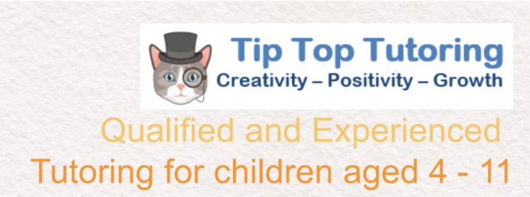
Tip Top Tutoring
Child Protection Policy

This Child Protection Policy applies to Tip Top Tutoring, a business run by Josephine Martin and all employees or volunteers working at Tip Top Tutoring and Confidence Clubs.

Policy Statement
We recognise our moral and statutory responsibility to safeguard and promote the welfare of all children. We make every effort to provide a safe and welcoming environment underpinned by a culture of openness where both children and adults feel secure, able to talk and believe that they are being listened to. We maintain an attitude of “it could happen here” where safeguarding is concerned.

Definitions Within this document:
Child protection is an aspect of safeguarding but is focused on how we respond to children who have been significantly harmed or are at risk of significant harm.
The term staff applies to all those working for or on behalf of Tip Top Tutoring at any venue, full time or part time, in either a paid or a voluntary capacity.
Child refers to all young people who have not yet reached their 18thbirthday. Overall, this will apply to pupils of our schools; however, the policy will extend to visiting children and students from other establishments.
Parent refers to birth parents and other adults in a parenting role for example adoptive parents, stepparents, guardians and foster carers.
Abuse could mean neglect, physical, emotional or sexual abuse or any combination of these. Parents, carers and other people can harm children either by direct acts and / or failure to provide proper care. Explanations of these are given within the procedure document.

Principles and Values
- Children have a right to feel secure and cannot learn effectively unless they do so.
- All children have a right to be protected from harm.
- All staff have a key role in prevention of harm and an equal responsibility to act on any suspicion or disclosure that may indicate a child is at risk of harm, either in the school or in the community, taking into account contextual safeguarding, in accordance with the guidance.
- We acknowledge that working in partnership with other agencies protects children and reduces risk and so we will engage in partnership working throughout the child protection process to safeguard children.
- Whilst the schools will work openly with parents as far as possible, it reserves the right to contact Children’s Social Care or the police, without notifying parents if this is believed to be in the child’s best interests.

Any individual can contact the Designated Safeguarding Lead (DSL) or the Deputy (DDSL) if they have concerns about a young person. Tip Top Tutoring works for three schools; Greenfields Juniors and Oakwood Infant Schools (Under the Greenoaks Federation) and Hook Junior School. See Annex 8 for contact details.

The Designated Safeguarding Leads [DSL] for Greenoaks Federation is:
Tom May, Executive Headteacher
The Deputy Designated Safeguarding Leads [DDSL] are:
Rachel Davies, Assistant Headteacher at Oakwood Infant School
Arline Green, Assistant Headteacher at Greenfields Junior School
Fiona Magowan, Assistant Headteacher at Greenfields Junior School

The Designated Safeguarding Leads [DSLs] for Hook Junior School are:
Lynn Powell, Head Teacher
The Deputy Designated Safeguarding Leads [DDSL] are:
Nicci Bailey, Deputy Head Teacher
Jo Carne, SENDco and Behaviour Lead
Andrew McLaren, Assistant Head Teacher, Upper School
Danielle Stewart, Assistant Head Teacher, Lower School

Referral
Following any concerns raised, the DSL will assess the information and consider if significant harm has happened or there is a risk that it may happen. If the evidence suggests the threshold of significant harm, or risk of significant harm has been reached, or if it is not clear if the threshold is met, the DSL will contact Children’s Social Care and, if appropriate, the police. If the DSL or DDSL is not available or there are immediate concerns, the staff member will refer directly to Children’s Social Care and the police if appropriate. We will use the guidance from NPCC to determine when to contact the police.

Generally, the DSL will inform the parents prior to making a referral. However, there are situations where this may not be possible or appropriate, particularly when informing parents/carers may place the child at further risk. N.B. The exception to this process will be in those cases of known FGM where there is a mandatory requirement for the teacher to report directly to the police. The DSL should also be made aware.

Confidentiality
• We maintain that all matters relating to child protection are to be treated as confidential and only shared as per the ‘Information Sharing Advice for Practitioners’ (DfE 2015) guidance.
• There is a lawful basis for child protection concerns to be shared with agencies who have a statutory duty for child protection.
• Information will be shared with individuals within the school who ‘need to know’.
• All staff are aware that they cannot promise a child to keep a disclosure confidential. We will educate pupils to recognise when they are at risk and how to get help when they need it through:
• The content of the curriculum will be tailored to the specific needs and vulnerabilities of individual children, including child who are victims of abuse, and children with SEND.
• Implementation of the Relationship, Health and Sex Education curriculum.
• An ethos which helps children to feel safe and able to talk freely about their concerns, believing that they will be listened to and valued.
• Every child having access to a ‘trusted adult’ in the school.

Dealing with concerns and allegations against staff
If a concern is raised about the practice or behaviour of a member of staff, this information will be recorded and passed to the Headteacher. The Headteacher will make an assessment to determine if the matter is a ‘low level concern’ or an ‘allegation’. The Local Authority Designated Officer (LADO) will be contacted for all allegations and the relevant guidance will be followed. If the Headteacher needs advice or guidance they will contact the LADO. If the allegation is against the Headteacher, the person receiving the allegation will contact the LADO or Chair of Governors directly [Annex 5].

Dealing with children abusing children
If a concern is raised that there is an allegation of a pupil abusing another pupil within the school, the ‘Child on child Abuse’ guidance will be followed [Annex 6].

Legal context Section 175 of the education act 2002; the Education (Independent School Standards) Regulations 2014; the Non-Maintained Special Schools (England) Regulations: Children Act 2004 & 1989 Guidance Hampshire Safeguarding Children Partnership protocols and guidance and their procedures Working Together to Safeguard Children (2023) Keeping Children Safe in Education (2024) FGM Act 2003 Mandatory Reporting Guidance (2016)

Policy review Tip Top Tutoring will review this policy at least annually in line with DfE, HSCP and HCC requirements and other relevant statutory guidance.

All staff have a key role to play in identifying concerns early and in providing help for children. To achieve this, they will:
- Establish and maintain an environment where children feel secure, are encouraged to talk and are listened to.
- Ensure children know that there are adults in the schools who they can approach if they are worried or have concerns.
- Plan opportunities within the curriculum for children to develop the skills they need to recognise, assess and manage risk appropriately and keep themselves safe.
- Attend training in order to be aware of and alert to the signs of abuse.
- Maintain an attitude of “it could happen here” with regards to safeguarding.
- Be aware that mental health problems can, in some cases, be an indicator that a child has suffered or is at risk of suffering abuse, neglect or exploitation.
- Recognise that abuse, neglect, or other adverse childhood experiences can have an impact on the mental health, behaviour, and education of children.
- Record their concerns if they are worried that a child is being abused and report these to the DSL as soon as is practical that day. If the DSL is not contactable immediately a DDSL should be informed.
- Be prepared to refer directly to social care, and the police if appropriate, if there is a risk of significant harm and the DSL or DDSL is not available.
- Follow the allegations procedures [Annex 5] if the disclosure is an allegation against a member of staff.
- Follow the procedures set out by the HSCP and take account of guidance issued by the DfE.
- Support pupils in line with their child protection plan • Treat information with confidentiality but never promising to “keep a secret”. Notify the DSL or DDSL of any child on a child protection plan or child in need plan who has unexplained absence.
- Have an understanding of Early Help and be prepared to identify and support children who may benefit from early help.
- Liaise with other agencies that support pupils and provide early help.
- Ensure they know who the DSL and DDSL are and know how to contact them.
- Have an awareness of the Child Protection Policy, the Behaviour Policy, the Staff Code of Conduct, child on child abuse procedures; procedures relating to the safeguarding response for children who go missing from education and the role of the DSL.

Child Protection Procedures Overview
The following procedures apply to all staff working for Tip Top Tutoring and will be covered by training to enable staff to understand their role and responsibility. The aim of our procedures is to provide a robust framework which enables staff to take appropriate action when they are concerned that a child is being harmed or is at risk of harm. The prime concern at all stages must be the interests and safety of the child. Where there is a conflict of interest between the child and an adult, the interests of the child must be paramount. All staff are aware that very young children, those with disabilities, special needs, certain medical conditions or with language deficit/English as a second language may have more difficulty in communicating concerns or feelings. They may be more likely to communicate concerns with behaviours rather than words. Additionally, staff will question the cause of knocks and bumps in children who have limited mobility, which will include children (for example younger siblings) visiting the site in addition to pupils.

If a member of staff suspects abuse, spots signs or indicators of abuse, or they have a disclosure of abuse made to them they must:
1. Make an initial record of the information and report it to the DSL immediately.
2. The DSL will consider if there is a requirement for immediate medical intervention, however urgent medical attention should not be delayed if the DSL is not immediately available.
3. Make an accurate record as soon as possible and within 24 hours of the occurrence, of all that has happened, including details of:
- Dates and times of their observations
- Dates and times of any discussions in which they were involved
- Any injuries
- Explanations given by the child / adult
- What action was taken
- Any actual words or phrases used by the child

This information is and signed. Notification that a record has been submitted must be in person to the DSLs or DDSL.

In the absence of the DSL or their Deputy, be prepared to refer directly to Children’s Social Care (and the police if appropriate) if there is the potential for immediate significant harm.

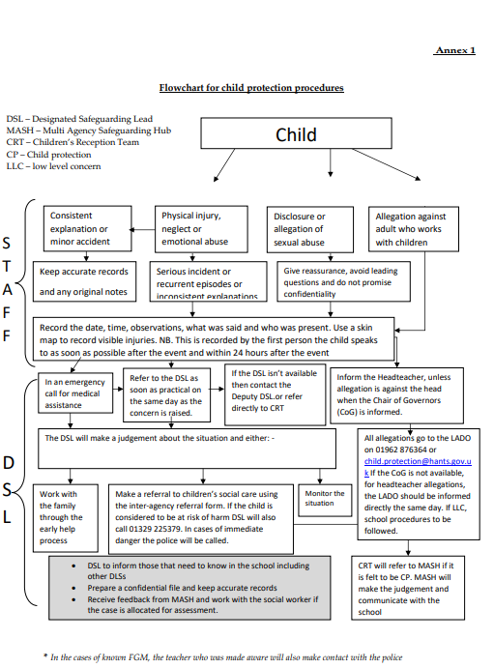

Annex 2

Safeguarding and Child Protection Recording and Reporting Form 2024 - 2025
This form should be completed in reference to the Child Protection and Safeguarding Policies. If a member of staff has a safeguarding concern, they must follow the procedures in the Child Protection Policy.

This includes but is not restricted to:
- ✓ Recording their concerns
- ✓ Reporting it to the DSL/Deputy DSL immediately
- ✓ Considering if this a requirement for immediate medical intervention and if so assistance must be called for
- ✓ Making an accurate record using the Safeguarding Recording and Reporting Form as soon as possible and within 24 hours of the occurrence
- ✓ Providing a body map if needed [Annex 3 Child Protection Policy]

It is the responsibility of the DSL/DDSL to review the incident and act in accordance with the Child Protection and Safeguarding Policy. All incidents must be recorded and include actions taken. A copy of this incident form should be attached to the electronic record and filed in the relevant Safeguarding record that MUST remain locked and secure.
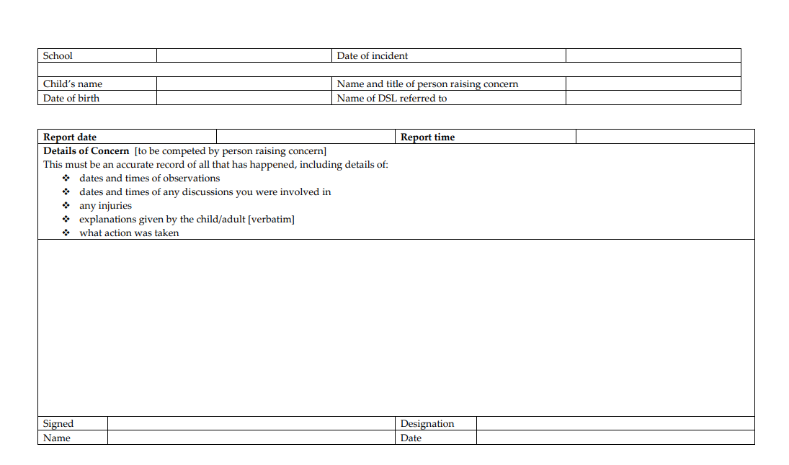

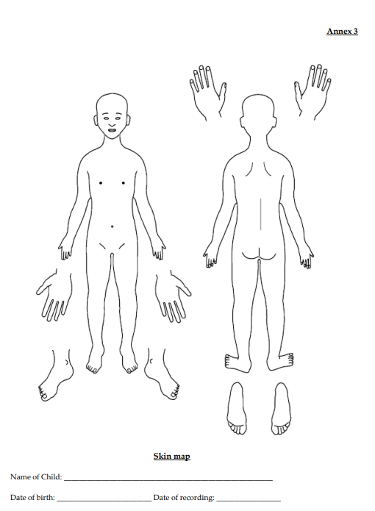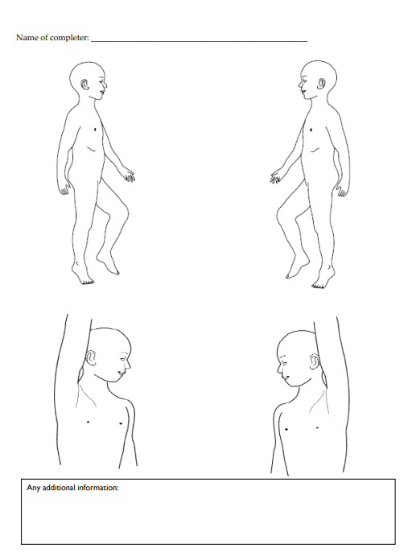

Annex 4
Dealing with Disclosures
Members of staff who are approached by a child should listen positively and try to reassure them. They cannot promise complete confidentiality and should explain that they may need to pass information to other professionals to help keep the child or other children safe. The degree of confidentiality should always be governed by the need to protect the child. Additional consideration needs to be given to children with communication difficulties and for those whose preferred language is not English. It is important to communicate with them in a way that is appropriate to their age, understanding and preferred communication method. All staff should know who the DSL is and who to approach if the DSL is unavailable. Ultimately, all staff have the right to make a referral to the police or social care directly and should do this if, for whatever reason, there are difficulties following the agreed protocol, e.g. they are the only adult on the school premises at the time and have concerns about sending a child home.

Guiding principles, the seven R’s
Receive:
- Listen to what is being said, without displaying shock or disbelief.
- Accept what is said and take it seriously.
- Make a note of what has been said as soon as practicable.

Reassure:
- Reassure the pupil, but only so far as is honest and reliable .
- Don’t make promises you may not be able to keep e.g. ‘I’ll stay with you’ or ‘everything will be alright now’ or ‘I’ll keep this confidential’.
- Do reassure e.g. you could say: ‘I believe you’, ‘I am glad you came to me’, ‘I am sorry this has happened’, ‘We are going to do something together to get help’.

Respond:
- Respond to the pupil only as far as is necessary for you to establish whether or not you need to refer this matter, but do not interrogate for full details.
- Do not ask ‘leading’ questions i.e. ‘did he touch your private parts?’ or ‘did she hurt you?’ Such questions may invalidate your evidence (and the child’s) in any later prosecution in court.
- Do not ask the child why something has happened.
- Do not criticise the alleged perpetrator; the pupil may care about him/her, and reconciliation may be possible.
- Do not ask the pupil to repeat it all for another member of staff. Explain what you have to do next and whom you have to talk to. Reassure the pupil that it will be a senior member of staff.

Report:
- share concerns with the DSL/DDSL as soon as possible in person. Record onto CPOMS or use the Safeguarding incident form if required
- if you are not able to contact your DSL or the Deputy, and the child is at risk of immediate harm, contact the children’s services department directly Record:
- If possible, make some very brief notes at the time, and write them up as soon as possible. • Keep your original notes on file.
- Record the date, time, place, persons present and noticeable nonverbal behaviour, and the words used by the child. If the child uses sexual ‘pet’ words, record the actual words used, rather than translating them into ‘proper’ words.
- Complete a body map to indicate the position of any noticeable bruising or marks.
- Record facts and observable things, rather than your ‘interpretations’ or ‘assumptions’.

Remember:
- Support the child: listen, reassure, and be available.
- Complete confidentiality is essential. Share your knowledge only with appropriate professional colleagues.
- Try to get some support for yourself if you need it.
- All staff should be aware that children may not feel ready or know how to tell somebody that they are being abused, exploited or neglected and/or they may not recognise their experiences as harmful.

Review (led by DSL):
- Has the action taken provided good outcomes for the child?
- Did the procedure work?
- were any deficiencies or weaknesses identified in the procedure? Have these been remedied?
- Is further training required? What happens next? It is important that concerns are followed up and it is everyone’s responsibility to ensure that they are.

The member of staff should be informed by the DSL what has happened following the report being made. If they do not receive this information, they should be proactive in seeking it out. If a staff member believes that their concerns have not been referred on or that the child remains at risk, they should initially ask the DSL to reconsider to ensure that the risks are understood. If this does not result in a satisfactory outcome, or the DSL rationale appears to miss the risk to the child, then the Whistleblowing procedures of the school should be followed. If the DSL is unhappy with the response from Children Social Care, they should consider following the HSCP escalation protocol. Receiving a disclosure can be upsetting for the member of staff and schools should have a procedure for supporting them after the disclosure. This might include reassurance that they have followed procedure correctly and that their swift actions will enable the allegations to be handled appropriately. For some staff, use of an employee-based counselling service may be appropriate.

Annex 5
Allegations against adults who work with children

Working Together to Safeguard Children (2018) states that organisations should have clear policies in line with those from the LSCP for dealing with allegations against people who work with children. Those policies should make a clear distinction between an allegation, a complaint, or a concern about the quality of care or practice. Allegations as defined by KCSiE should be reported to the Local Authority Designated Officer (LADO). Complaints or concerns can be managed independently by the school under internal procedures.

Complaints could include:
- Breaches of the code of Conduct
- Any breach of data protection or confidentiality
- Poor behaviour management
- Inappropriate use of social media
- Misadministration of medication

Concerns could include:
- Inappropriate use of language, shouting or swearing.
- Discussing personal or sexual relationships with, or in the presence, of pupils.
- Making (or encouraging others to make) unprofessional comments which scapegoat, demean or humiliate children, or might be interpreted as such.

Lower-Level Concerns LLC’s, which do not reach the allegations harm threshold (or complaints criteria) should be dealt with under our school LLC procedure.

Procedure for Allegations that meet the harm threshold
This procedure should be used in all cases in which it is alleged a member of staff, supply staff, volunteer, Governor, or another adult who works with children has either:-
- Behaved in a way that has harmed a child, or may have harmed a child; or
- Possibly committed a criminal offence against or related to a child; or
- Behaved towards a child or children in a way that indicates he or she would pose a risk of harm to children; or
- Behaved or may have behaved in a way that indicates they may not be suitable to work with children.

When considering allegations of suitability, (the fourth criteria above) the LADOs would consider the following situations:
- Parents of children who are placed on a CIN plan or are receiving Early Help;
- Arrests for offences against adults;
- Presentation to other professionals around mental health, domestic abuse and/or substance misuse;
- Extreme political or religious viewpoints which could be considered Hate Crime;
- Concerns about behaviour in their private lives which may impact on children .

The LADO criteria for intervention in any of these situations will be assessed against the likelihood and impact of transferable risk to children.

In line with our referral process:
- Report any concerns about the conduct of any member of staff or volunteer to the Headteacher as soon as possible.
- If an allegation is made against the Headteacher, the concerns need to be raised with the Chair of Governor as soon as possible. If the Chair of Governors is not available, then the LADO should be contacted directly.
- There may be situations when the Headteacher or Chair of Governors will want to involve the police immediately if the person is deemed to be an immediate risk to children or there is evidence of a possible criminal offence.
- Once an allegation has been received by the Headteacher or Chair of Governors they will contact the LADO on 01962 876364 or child.protection@hants.gov.uk as soon as possible and before carrying out any investigation .
- Inform the parents of the allegation unless there is a good reason not to.

In liaison with the LADO, the school will determine how to proceed and if necessary, the LADO will refer the matter to Children’s Social Care and/or the police. When receiving information from outside agencies about school staff, the LADO will assess the potential for transferable risk, and make disclosure to the school where there is a likelihood of transferable risk to children and there is a pressing need. If the matter is investigated internally, the LADO will advise the school to seek guidance from their personnel/HR provider in following procedures set out in chapter 4 of ‘Keeping Children Safe in Education’ (2024) and the HSCP procedures.

Supply Staff
While supply staff are not the employee of the school, it is still required that the school report the allegation to the LADO. If the matter requires an internal investigation, this will be carried out by the school in liaison with a HR rep (acting as the employer) from the supply agency.

Lower-Level Concerns (LLCs)
The LLC policy is part of the whole school approach to safeguarding. The purpose of the policy is to encourage an open and transparent culture, which enables the school to identify concerning, problematic or inappropriate behaviour at an early stage. It should also empower staff to share LLCs with the DSL. LLCs will be managed independently by the school under internal procedures. Examples of LLCs include, but is not limited to: - • Being over friendly with children; • Having favourites; • Taking photographs of children on their mobile phone; • Engaging with a child on a one-to-one basis in a secluded area or behind a closed door; • Using inappropriate sexualised, intimidating or offensive language; • Humiliating pupils.

The LLC policy will: - • Ensure that staff are clear about what constitutes appropriate behaviour, and are confident in distinguishing expected and appropriate behaviour from concerning, problematic or inappropriate behaviour, in themselves and others; • Empower staff to share any low-level safeguarding concerns with the DSL. • Address unprofessional behaviour and support the individual to correct this at an early stage. • Provide a responsive, sensitive and proportionate handling of such concerns when they are raised. • Help identify any weakness in the school safeguarding system.

In line with the LLC policy: - • All LLCs will be shared responsibly with the DSL, recorded in writing and dealt with in an appropriate and timely manner. • All LLCs will be reviewed, so that potential patterns of concerning, problematic or inappropriate behaviour can be identified. • If LLCs are found to be escalating and are reaching the harm threshold, A referral will be made to the LADO. If there is any doubt about the level at which behaviour needs to be addressed, LADO advice will be taken.

Annex 6
Sexual violence and sexual harassment between children in schools

Child on child Abuse Policy HSCP have developed a child on child abuse toolkit to provide schools with additional guidance: Child on Child abuse - Hampshire SCP as well as the child sexual abuse toolkit: Child Sexual Abuse - Hampshire SCP Context This policy is about how staff should respond to all reports and concerns of child-on-child sexual violence and sexual harassment, including those that have happened outside of school premises, and or online. All staff are advised to maintain an attitude of “It could happen here”. Schools not recognising, acknowledging or understanding the scale of harassment and abuse, and /or downplaying some behaviours relating to abuse can lead to a culture of unacceptable behaviour, an unsafe environment and in a worst-case scenario a culture that normalises abuse leading to children accepting it as normal and not coming forward to report it. Sexual violence and sexual harassment can occur between two children of any age and sex. It can also occur through a group of children sexually assaulting or sexually harassing a single child or group of children.

Children who are victims of sexual violence and sexual harassment will likely find the experience stressful and distressing. This will, in all likelihood, adversely affect their educational attainment as well as their emotional well-being. Sexual violence and sexual harassment exist on a continuum and may overlap; they can occur online and offline (both physically and verbally) and are never acceptable. It is important that all victims are taken seriously and offered appropriate support. It is also important to recognise that some perpetrators may themselves also be victims. Reports of sexual violence and sexual harassment are extremely complex to manage. It is essential that victims are protected, offered appropriate support and every effort is made to ensure their education is not disrupted. It is also important that other children, adult students and school staff are supported and protected as appropriate.

Policy We believe that all children have a right to attend school and learn in a safe environment. Children should be free from harm by adults in the school and other children. We recognise that children are capable of abusing their peers and this will be dealt with under our child protection policy and in line with KCSiE Chapter 5 (2024). This policy is underpinned by the principle that there is a zero-tolerance approach to sexual violence and sexual harassment. We are clear that sexual violence and sexual harassment is not acceptable, will never be tolerated and is not an inevitable part of growing up.

We will minimise the risk of child-on-child abuse by:
Prevention: • Taking a whole school approach to safeguarding & child protection. • Providing training to staff. • Providing a clear set of values and standards, underpinned by the school’s behaviour policy and pastoral support system, and by a planned programme of evidence-based content delivered through the curriculum. • Engaging with specialist support and interventions.
Responding to reports of sexual violence and sexual harassment: • Children making a report of sexual violence or sexual harassment will be taken seriously, kept safe and be well supported. • Understanding that our initial response to a report from a child is incredibly important and can encourage or undermine the confidence of victims of sexual violence and harassment to report or to come forward in the future. • If the report includes an online element, staff will be mindful of the Searching, Screening and Confiscation: advice for schools (DfE 2022) guidance. • Staff taking the report will inform the DSL or their Deputy as soon as practicably possible but at least within 24 hours. • Staff taking a report will never promise confidentiality. • Parents or carers will normally be informed (unless this would put the child at greater risk) • If a child is at risk of harm, is in immediate danger, or has been harmed, a referral will be made to Children’s Social Care (01329 225379).

Risk Assessment: Following a report, the DSL will make an immediate risk and needs assessment on a case-by-case basis. The Risk assessment will consider: • The victim, especially their protection and support. • The alleged perpetrator, their support needs and any discipline action. • All other children at the school. • The victim and the alleged perpetrator sharing classes and space at school. The risk assessment will be recorded and kept under review. Where there has been other professional intervention and/or other specialist risk assessments, these professional assessments will be used to inform the school’s approach to supporting and protecting pupils. Action: The DSL will consider: • The wishes of the victim and parent.

The nature of the incident including whether a crime has been committed and the harm caused. • Ages of the children involved. • Developmental stages of the children. • Any power imbalance between the children. • Any previous incidents. • Ongoing risks. • Other related issues or wider context. Options: The DSL will manage the report with the following options: • Manage internally • Early Help • Refer to Children’s Social Care • Report to the police (generally in parallel with a referral to Social Care) Ongoing Response: • All concerns, discussions and decisions made, and the reasons for those decisions, should be recorded in writing. Records should be reviewed so that potential patterns of concerning, problematic or inappropriate behaviour can be identified and addressed. • The DSL will keep the risk assessment under review. • The DSL will manage each report on a case-by-case basis and will keep the risk assessment under review. • Where there is a criminal investigation, the alleged perpetrator should be removed from any classes they share with the victim. The DSL will consider how best to keep the victim and perpetrator a reasonable distance apart on school premises and on transport where appropriate. • In all but the most exceptional of circumstances, a sexual assault is likely to constitute a serious breach of discipline and lead to the view that allowing the perpetrator to remain in the same school would seriously harm the education or welfare of the victim (and potentially other pupils or students). • Where a criminal investigation into sexual assault leads to a conviction or caution, the school will, if it has not already, consider any suitable sanctions in light of their behaviour policy, including consideration of permanent exclusion. Where the perpetrator is going to remain at the school, the principle would be to continue keeping the victim and perpetrator in separate classes and continue to consider the most appropriate way to manage potential contact on school premises and transport. The nature of the conviction or caution and wishes of the victim will be especially important in determining how to proceed in such cases. • The victim, alleged perpetrator and other witnesses (children& adults) will receive appropriate support and safeguards on a case-by-case basis.

When ongoing support is required by the victim, the victim should be asked whether they would find it helpful to have a designated trusted adult to talk about their needs. The choice of any such adult should be made by the victims (as far as reasonably possible) and this choice should be supported. • The school will take any disciplinary action against the alleged perpetrator in line with behaviour and discipline in schools. • The school recognises that taking disciplinary action and providing appropriate support are not mutually exclusive actions and will occur at the same time if necessary. Unsubstantiated, unfounded, false, or malicious reports: • If a report is determined to be unsubstantiated, unfounded, false or malicious, the designated safeguarding lead should consider whether the child and/or the person who has made the allegation is in need of help or may have been abused by someone else and whether this is a cry for help. In such circumstances, a referral to children’s social care may be appropriate. • If a report is shown to be deliberately invented or malicious, the school, should consider whether any disciplinary action is appropriate against the individual who made it as per their own behaviour policy. Physical Abuse While a clear focus of child-on-child abuse is around sexual abuse and harassment, physical assaults and initiation violence and rituals from pupils to pupils can also be abusive. These are equally not tolerated and if it is believed that a crime has been committed, will be reported to the police. The principles from the anti-bullying policy will be applied in these cases, with recognition that any police investigation will need to take priority.

Keeping Children Safe in Education Safe Working Declaration All members of staff [this includes by definition temporary and supply staff], Governors and regular volunteers will be asked to sign this code of practice as part of induction. They will be expected to abide by it at all times. It is important that adults know how to keep children safe in education and how to conduct themselves in a way which minimises the risk of finding themselves the subject of a child protection or criminal allegation. All staff, governors and volunteers must: • Have read, understood and agree to abide by Keeping Safe in Education 2024 [Part 1]. • Have attended a safeguarding briefing, including Prevent and cyber security and agree to abide by the schools’ Keeping Children Safe expectations and procedures. All staff, Governors and volunteers must work within the Keeping Children Safe Code of Conduct: They must: ✓ Work in an open and transparent way, avoiding any actions that would lead someone to question their motivation or intent ✓ Dress appropriately for their role ✓ Avoid unnecessary physical contact with children. If physical contact is made: Ensure an awareness of and understand the rules concerning physical restraint ➢ Where it is essential for educational or safety reasons, gain pupil permission for that contact wherever possible. ➢ To remove a pupil from a dangerous situation or an object from a pupil to prevent either harm to self or others, then this should be recorded on the Physical Intervention Form and reported to the Executive Headteacher or Assistant Headteacher. It should not be secretive, even if accidental contact was made, it should be reported. ➢ Understand their position of power and influence over children and not misuse this in any way. This includes but is not limited to: ➢ Accepting regular gifts from children ➢ Giving personal gifts to children ✓ Recognise their influence and not engage in activities outside of the school that might compromise the school or your professional integrity ✓ Not establish or seek to establish social contact with pupils outside of school. This includes: ➢ Communication with pupils in appropriate ways, including personal emails and mobile telephones ➢ Passing on home address, personal phone numbers, email or other personal details to pupils ➢ The transportation of pupils in vehicles without school approval and completion of necessary paperwork ➢ Contact through social networking sites or other internet-based communications ➢ Housing children overnight ✓ Only use email contact with pupils via the school system ✓ Be careful about recording images of pupils and do this only when it an approved educational activity and done on a device owned by school when parents have given their express permission ✓ Ensure that all sex and relationships education is taught and addressed in accordance with school policies ✓ Allow children to change clothes with levels of respect and privacy appropriate to age, gender, culture and circumstance ✓ Avoid closed door situations, working one to one or conferring undue special attention ✓ Only meet with pupils in closed rooms when given permission to do so by a senior member of staff ✓ Always treat children with courtesy and respect ✓ Respect confidentiality at all times ✓ Only use school IT systems and agree to abide by the Acceptable Use of ICT policy ✓ Make sure that personal mobile devices are switched off whilst at school

In addition, they must not: • use any information to intimidate, humiliate or embarrass a child • Allow a child to be over familiar though personal contact e.g. climbing on laps, touching inappropriately, excessive need for physical contact • Establish unnecessary contact with pupils outside of the school • Allow boundaries to become blurred in more informal situations e.g. school trips, clubs • Discuss or share information about children outside of school • Use social networking to discuss the school or children • Take photos or videos of children or adults at school • Not access inappropriate material via the internet • Use physical punishment of any kind • Attribute touch to their contact style with pupils All staff, volunteers and Governors must immediately inform the Assistant Headteacher or Headteacher if: ✓ There are any incidents of issues that might lead to concerns being raised about your own or others conduct towards a child.

There is any suggestion a pupil may be infatuated with you or taking and above normal interest in you. ✓ There are any Safeguarding or child protection concerns relating to pupils. ✓ There are any concerns relating to a member of staff’s behaviour or conduct towards pupils.

All staff, volunteers and Governors must immediately inform Chair of Governors or Local Area Designated Officer [LADO] if there are any concerns relating to the conduct of the Headteacher. The contact details for the Chair of Governors and LADO are displayed in the school office and staff room.

_______________________________________________________________________________________

I confirm that I have read and understood this Safe Working Declaration and by signing this form, I am agreeing to abide by the expectations and to follow all guidance. I have been made aware of the key principles of the Child Protection policy, including, the procedure for reporting concerns, the requirement for pre-employment checks to be undertaken as appropriate, and the boundaries and behaviours that are acceptable and appropriate within the school context, and those which are not.

I understand the Code of Conduct and have read Keeping Children Safe in Education (Part 1): information for all school staff. I understand that adults are in a position of trust when working with young people and that appropriate boundaries must be maintained at all times. This means that language, demeanour and content of conversations, whether in person, face-to-face or via electronic means must all be professional and relevant.

Name:________________________________________ Role ____________________________________

Signature________________________________________ Date___________________________________

Annex 7

What is child abuse? The following definitions are taken from Working Together to Safeguard Children HM Government (2018). In addition to these definitions, it should be understood that children can also be abused by being sexually exploited, honour-based violence, forced marriage or female genital mutilation. To support the local context, all staff have access to the Hampshire safeguarding children partnership (HSCP) threshold chart.

What is abuse and neglect? Abuse and neglect are forms of maltreatment of a child. Somebody may abuse or neglect a child by inflicting harm, or by failing to act to prevent harm. Children may be abused in a family or in an institutional or community setting, by those known to them or, more rarely, by a stranger. They may be abused by an adult or adults, or another child or children. Physical abuse Physical abuse may involve hitting, shaking, throwing, poisoning, burning or scalding, drowning, suffocating, or otherwise causing physical harm to a child. Physical harm may also be caused when a parent or carer fabricates the symptoms of, or deliberately induces, illness in a child.

Emotional abuse The persistent emotional maltreatment of a child such as to cause severe and persistent adverse effects on the child’s emotional development. It may involve conveying to a child that they are worthless or unloved, inadequate, or valued only insofar as they meet the needs of another person. It may include not giving the child opportunities to express their views, deliberately silencing them or ‘making fun’ of what they say or how they communicate. It may feature age or developmentally inappropriate expectations being imposed on children. These may include interactions that are beyond a child’s developmental capability, as well as overprotection and limitation of exploration and learning, or preventing the child participating in normal social interaction. It may involve seeing or hearing the ill-treatment of another. It may involve serious bullying (including cyber bullying), causing children frequently to feel frightened or in danger, or the exploitation or corruption of children. Some level of emotional abuse is involved in all types of maltreatment of a child, although it may occur alone.

Sexual abuse Involves forcing or enticing a child or young person to take part in sexual activities, not necessarily involving a high level of violence, whether or not the child is aware of what is happening. The activities may involve physical contact, including assault by penetration (for example, rape or oral sex) or non-penetrative acts such as masturbation, kissing, rubbing and touching outside of clothing. They may also include non-contact activities, such as involving children in looking at, or in the production of, sexual images, watching sexual activities, encouraging children to behave in sexually inappropriate ways, or grooming a child in preparation for abuse (including via the internet). Sexual abuse is not solely perpetrated by adult males. Women can also commit acts of sexual abuse, as can other children.

Neglect Neglect is the persistent failure to meet a child’s basic physical and/or psychological needs, likely to result in the serious impairment of the child’s health or development. Neglect may occur during pregnancy as a result of maternal substance abuse. Once a child is born, neglect may involve a parent or carer failing to: • Provide adequate food, clothing and shelter (including exclusion from home or abandonment) • Protect a child from physical and emotional harm or danger • Ensure adequate supervision (including the use of inadequate care-givers) • Ensure access to appropriate medical care or treatment. It may also include neglect of, or unresponsiveness to, a child’s basic emotional needs. The HSCP neglect strategy is used to provide a more detailed summary of neglect and the local thresholds for referrals. Indicators of abuse Neglect The nature of neglect Neglect is a lack of parental care but poverty and lack of information or adequate services can be contributory factors. Far more children are registered to the category of neglect on child protection plans than to the other categories. As with abuse, the number of children experiencing neglect is likely to be much higher than the numbers on the plans. Neglect can include parents or carers failing to: • Provide adequate food, clothing and shelter • Protect a child from physical and emotional harm or danger • Ensure adequate supervision or stimulation • Ensure access to appropriate medical care or treatment NSPCC research has highlighted the following examples of the neglect of children under 12: • Frequently going hungry • Frequently having to go to school in dirty clothes • Regularly having to look after themselves because of parents being away or having problems such as drug or alcohol misuse. • Being abandoned or deserted • Living at home in dangerous physical conditions • Not being taken to the doctor when ill • Not receiving dental care Neglect is a difficult form of abuse to recognise and is often seen as less serious than other categories. It is, however, very damaging: children who are neglected often develop more slowly than others and may find it hard to make friends and fit in with their peer group.

Neglect is often noticed at a stage when it does not pose a risk to the child. The duty to safeguard and promote the welfare of children (What to do if You’re Worried a Child is Being Abused DfE 2015) would suggest that an appropriate intervention or conversation at this early stage can address the issue and prevent a child continuing to suffer until it reaches a point when they are at risk of harm or in significant need. Neglect is often linked to other forms of abuse, so any concerns school staff have should at least be discussed with the DSL. Indicators of neglect The following is a summary of some of the indicators that may suggest a child is being abused or is at risk of harm. It is important to recognise that indicators alone cannot confirm whether a child is being abused. Each child should be seen in the context of their family and wider community and a proper assessment carried out by appropriate persons. What is important to keep in mind is that if you feel unsure or concerned, do something about it. Don’t keep it to yourself. The HSCP neglect toolkit provides a more detailed list of indicators of neglect and is available to all staff Physical indicators of neglect • Constant hunger and stealing food • Poor personal hygiene - unkempt, dirty or smelly • Underweight • Dress unsuitable for weather • Poor state of clothing • Illness or injury untreated

Behavioural indicators of neglect • Constant tiredness • Frequent absence from school or lateness • Missing medical appointments • Isolated among peers • Frequently unsupervised • Stealing or scavenging, especially food • Destructive tendencies Emotional abuse The nature of emotional abuse Most harm is produced in low warmth, high criticism homes, not from single incidents. Emotional abuse is difficult to define, identify/recognise and/or prove. Emotional abuse is chronic and cumulative and has a long-term impact. All kinds of abuse and neglect have emotional effects although emotional abuse can occur by itself. Children can be harmed by witnessing someone harming another person – as in domestic violence. It is sometimes possible to spot emotionally abusive behavior from parents and carers to their children, by the way that the adults are speaking to, or behaving towards children. An appropriate challenge or intervention could affect positive change and prevent more intensive work being carried out later on. Indicators of emotional abuse Developmental issues • Delays in physical, mental and emotional development • Poor school performance • Speech disorders, particularly sudden disorders or changes. Behaviour • Acceptance of punishment which appears excessive • Over-reaction to mistakes • Continual self-deprecation (I’m stupid, ugly, worthless etc) • Neurotic behaviour (such as rocking, hair-twisting, thumb-sucking) • Self-mutilation • Suicide attempts • Drug/solvent abuse • Running away • Compulsive stealing, scavenging • Acting out • Poor trust in significant adults • Regressive behaviour – e.g., wetting • Eating disorders • Destructive tendencies • Neurotic behaviour • Arriving early at school, leaving late

Social issues • Withdrawal from physical contact • Withdrawal from social interaction • Over-compliant behaviour • Insecure, clinging behaviour • Poor social relationships Emotional responses • Extreme fear of new situations • Inappropriate emotional responses to painful situations (“I deserve this”) • Fear of parents being contacted • Self-disgust • Low self-esteem • Unusually fearful with adults • Lack of concentration, restlessness, aimlessness • Extremes of passivity or aggression

Physical abuse The nature of physical abuse Most children collect cuts and bruises quite routinely as part of the rough and tumble of daily life. Clearly, it is not necessary to be concerned about most of these minor injuries. But accidental injuries normally occur on the bony prominences – e.g., shins. Injuries on the soft areas of the body are more likely to be inflicted intentionally and should therefore make us more alert to other concerning factors that may be present. A body map (annex 3) can assist in the clear recording and reporting of physical abuse. The body map should only be used to record observed injuries and no child should be asked to remove clothing by a member of staff of the school. Indicators of physical abuse / factors that should increase concern • Multiple bruising or bruises and scratches (especially on the head and face) • Clusters of bruises - e.g., fingertip bruising (caused by being grasped) • Bruises around the neck and behind the ears - the most common abusive injuries are to the head. • Bruises on the back, chest, buttocks, or on the inside of the thighs • Marks indicating injury by an instrument - e.g., linear bruising (stick), parallel bruising (belt), marks of a buckle. • Bite marks • Deliberate burning may also be indicated by the pattern of an instrument or object – e.g., electric fire, cooker, cigarette. • Scalds with upward splash marks or tide marks • Untreated injuries • Recurrent injuries or burns • Bald patches

In the social context of the school, it is normal to ask about a noticeable injury. The response to such an enquiry is generally light-hearted and detailed. So, most of all, concern should be increased when: • The explanation given does not match the injury • The explanation uses words or phrases that do not match the vocabulary of the child (adult’s words). • No explanation is forthcoming • The child (or the parent/carer) is secretive or evasive • The injury is accompanied by allegations of abuse or assault You should be concerned if the child or young person: • Is reluctant to have parents/carers contacted • Runs away or shows fear of going home • Is aggressive towards themselves or others • Flinches when approached or touched • Is reluctant to undress to change clothing for sport • Wears long sleeves during hot weather

Is unnaturally compliant in the presence of parents/carers. • Has a fear of medical help or attention • Admits to a punishment that appears excessive. Sexual abuse The nature of sexual abuse Sexual abuse is often perpetrated by people who are known and trusted by the child – e.g., relatives, family friends, neighbours, babysitters, people working with the child in school, faith settings, clubs or activities. Children can also be subject to child sexual exploitation. Sexual exploitation is seen as a separate category of sexual abuse. Indicators of CSE can be found in the schools safeguarding policy. Characteristics of child sexual abuse: • It is often planned and systematic - people do not sexually abuse children by accident, though sexual abuse can be opportunistic. • Grooming the child – people who abuse children take care to choose a vulnerable child and often spend time making them dependent. • Grooming the child’s environment - abusers try to ensure that potential adult protectors (parents and other carers especially) are not suspicious of their motives. Most people who sexually abuse children are men, but some women sexually abuse too. Indicators of sexual abuse

Physical observations: • Damage to genitalia, anus or mouth • Sexually transmitted diseases • Unexpected pregnancy, especially in very young girls • Soreness in genital area, anus or mouth and other medical problems such as chronic itching • Unexplained recurrent urinary tract infections and discharges or abdominal pain Behavioural observations: • Sexual knowledge inappropriate for age • Sexualised behaviour or affection inappropriate for age • Sexually provocative behaviour/promiscuity • Hinting at sexual activity Inexplicable decline in school performance • Depression or other sudden apparent changes in personality as becoming insecure or clinging • Lack of concentration, restlessness, aimlessness • Socially isolated or withdrawn • Overly-compliant behaviour • Acting out, aggressive behaviour • Poor trust or fear concerning significant adults • Regressive behaviour, • Onset of wetting, by day or night; nightmares Onset of insecure, clinging behaviour • Arriving early at school, leaving late, running away from home • Suicide attempts, self-mutilation, self-disgust • Suddenly drawing sexually explicit pictures • Eating disorders or sudden loss of appetite or compulsive eating • Regressing to younger behaviour patterns such as thumb sucking or bringing out discarded cuddly toys • Become worried about clothing being removed • Trying to be ‘ultra-good’ or perfect; overreacting to criticism.

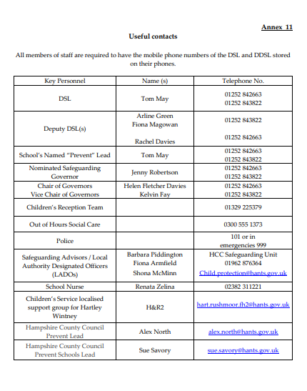
Annex 8
Greenoaks Federation

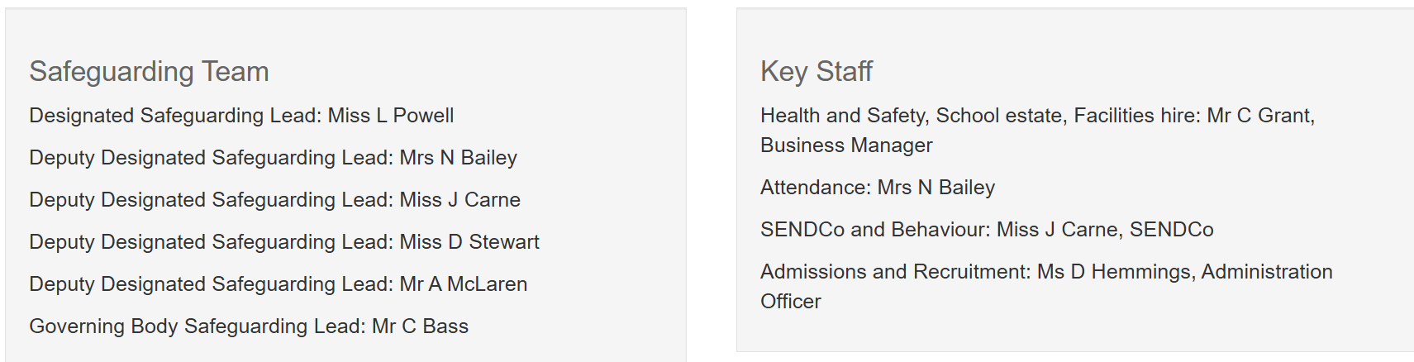
Hook Junior School

